
Dashboard Design

Date | 27 October 2026
Team ID | Individual Project
Project Name | EV Market Performance & Insights Dashboard
Maximum Marks | 5 Marks

Activity 1: Interactive and visually appealing dashboards
Creating an effective Streamlit dashboard involves presenting business data stored in Snowflake through clear, interactive, and easy-to-understand visualizations. Students should design the dashboard so that users can quickly understand important KPIs, trends, comparisons, and business insights.
- Clear and Intuitive Layout
- Use Appropriate Visualizations
- Colour and Theming
- Interactive Filters and Slicers
- Drill-Down Capabilities
- Responsive Design
- Custom Visuals and Icons
- Use of Infographics

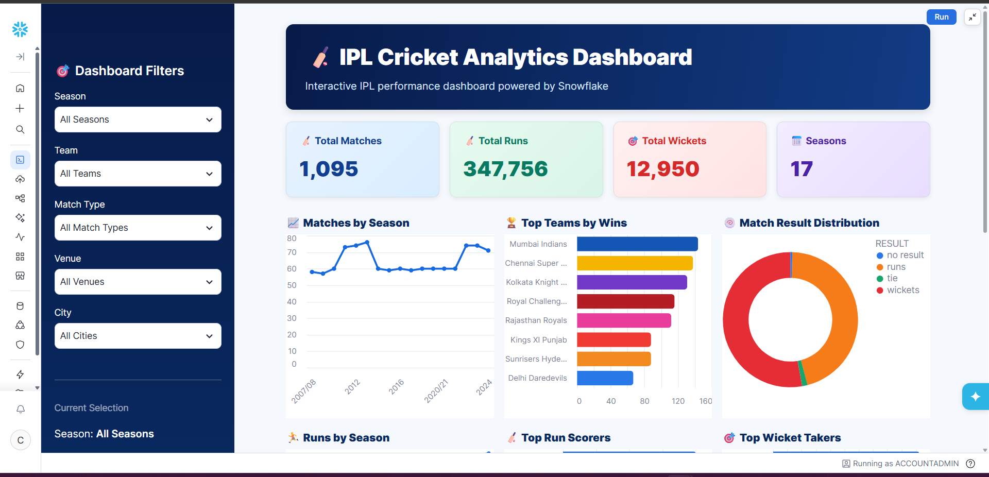
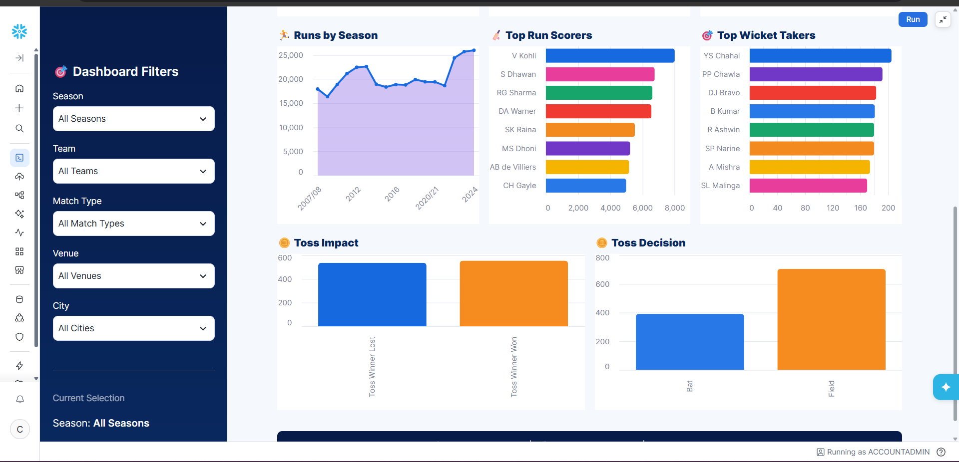
Note: Highlight the major outcomes in form of bullet points

Here are five potential outcomes from the dashboard image provided:

- Batting performance is dominated by a few key players
V. Kohli leads the Top Run Scorers chart, followed by players such as S. Dhawan, RG Sharma, and DA Warner. This highlights the importance of high-performing batsmen.
- Wicket-taking performance is concentrated among leading bowlers
YS Chahal ranks highest in the Top Wicket Takers chart, followed by PP Chawla and DJ Bravo, indicating that a relatively small group of bowlers has contributed significantly to wicket-taking.
- Fielding/toss decisions appear to have an impact on match outcomes
The Toss Impact and Toss Decision charts show differences between winning after winning the toss and choosing to bat vs. field. This can be used to investigate whether the toss provides a meaningful advantage.
- IPL match activity and scoring have grown over the seasons
The Matches by Season and Runs by Season charts show variation and an overall increase in IPL activity and run production across seasons, with particularly high run totals in later seasons.
Overall outcome: The dashboard suggests that IPL success is influenced by a combination of strong teams, elite batting and bowling performers, match/toss decisions, and changing scoring patterns across seasons.

Major Outcomes
• The dashboard summarizes approximately 199,999 distinct Vehicle Ids.\n• Average battery capacity is approximately 78.24 kWh.\n• Average driving range is approximately 324.5 km.\n• A manufacturer chart supports comparison of EV record counts across available manufacturers.\n• A manufacturing-country chart shows the distribution of EV records by country.
Dashboard Public Link
https://public.tableau.com/views/EVMarketAnalysisDashboard_17930190186570/Dashboard1
Project-specific note: This template describes a Snowflake/Streamlit-style workflow, but this project is implemented in Tableau. The relevant design is the Tableau dashboard with three KPI cards and two category charts. Snowflake and Streamlit are not claimed as used.
Dashboard Public Link: https://public.tableau.com/views/EVMarketAnalysisDashboard_17930190186570/Dashboard1

